**Some Notes About Sass**

**Things Learned from this Project**

1. What is Sass?
2. Sass in Production:

* When working with Sass, you only need 1 main.scss file, the main.css file will be generated with the main.scss file
* You can create more Scss file but remember to have the underscore (_) in the beginning and import the new scss file into the main.scss file

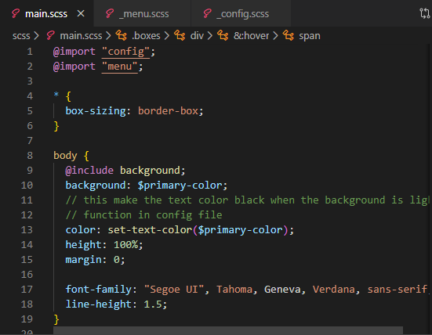

* Remember to link the **main.css** file for styling in html file. This is because browser doesn’t read scss files

1. Things Learned from this project (Only coding related):

* How to use Variables and Function in SASS and in CSS
* How to do animation in css using **transform**, **transition** properties:

+, For hover effect animation, you don’t need to use javascript, CSS can take care of it

* Review Grid and Flex boxes
* How to make the back ground blur so that the content behind are visible using **opacity** attribute